NAME:-G.Ayyappa venkata sai
REG NO:-192372111

LAB EXERCISES

EXP-1:
AIM: Write a C program to simulate a Deterministic Finite Automata (DFA) for the given
language representing strings that start with a and end with a
CODE:
#include <stdio.h>
#include <string.h>
int main() {
char str[100];
int i, n;
printf("Enter the string: ");
scanf("%s", str);
n = strlen(str);
if (str[0] == 'a' && str[n - 1] == 'a') {
printf("String is Accepted.\n");
} else {
printf("String is Rejected.\n");
}
return 0;
}
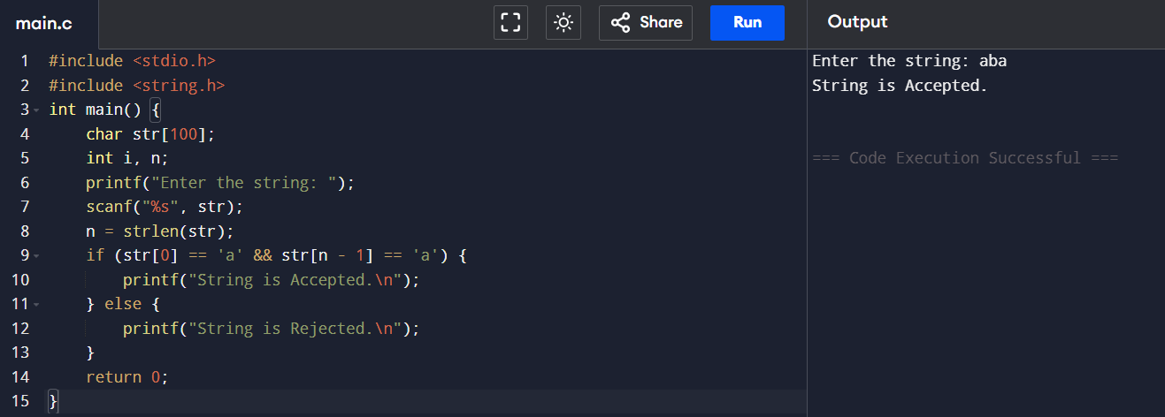
OUTPUT:

EXP-2:
AIM: Write a C program to simulate a Deterministic Finite Automata (DFA) for the given
language representing strings that start with 0 and end with 1
CODE:
#include <stdio.h>
#include <string.h>
int main()
{
char str[100];
int n;
printf("Enter the string: ");
scanf("%s", str);
n = strlen(str);
if (str[0] == '0' && str[n - 1] == '1')
printf("String is Accepted.\n");
else
printf("String is Rejected.\n");
return 0;
}
OUTPUT:
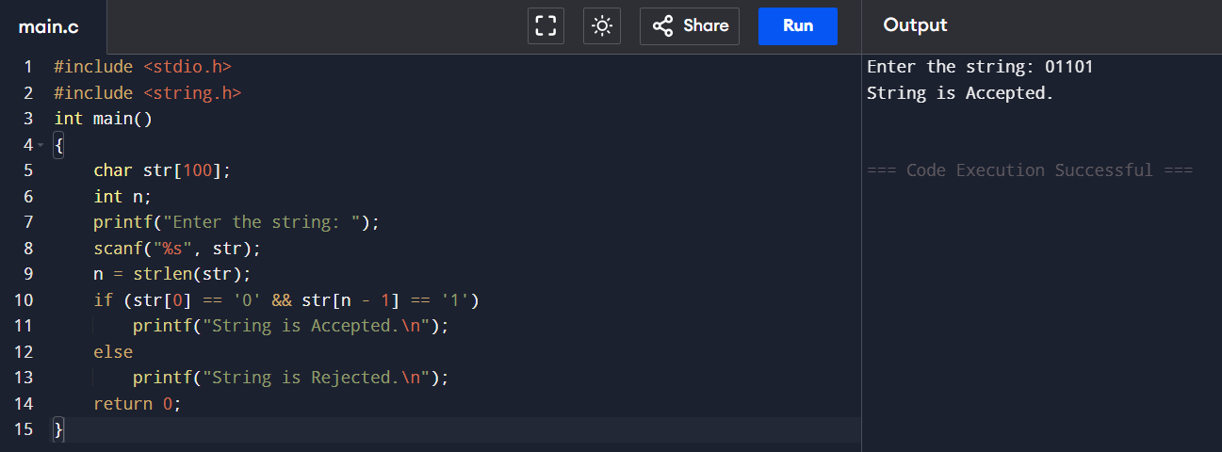

EXP-3:
AIM: Write a C program to check whether a given string belongs to the language defined by a Context Free Grammar (CFG) S → 0A1 A → 0A | 1A | ε
CODE:
#include <stdio.h>
#include <string.h>
int main()
{
char str[100];
int n;
printf("Enter the string: ");
scanf("%s", str);
n = strlen(str);
if (n >= 2 && str[0] == '0' && str[n - 1] == '1')
printf("String belongs to the CFG.\n");
else
printf("String does not belong to the CFG.\n");

return 0;
}
OUTPUT:
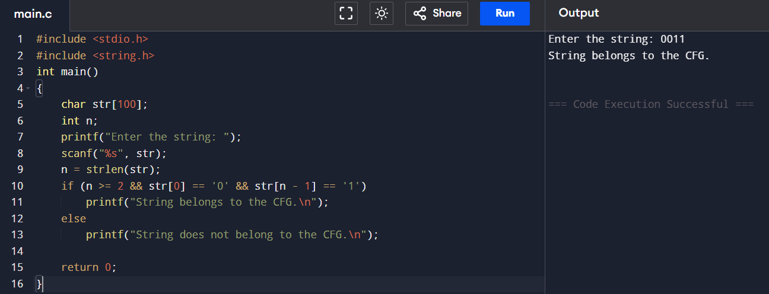

EXP-4:
AIM: Write a C program to check whether a given string belongs to the language defined by a Context Free Grammar (CFG) S → 0S0 | 1S1 | 0 | 1 | ε
CODE:
#include <stdio.h>
#include <string.h>
int main() {
char s[100];
int i, n, f = 1;
printf("Enter the string: ");
scanf("%s", s);
n = strlen(s);
for(i = 0; i < n/2; i++)
if(s[i] != s[n-i-1]) {
f = 0;
break;
}
if(f)
printf("String belongs to CFG");
else
printf("String does not belong to CFG");
return 0;
}
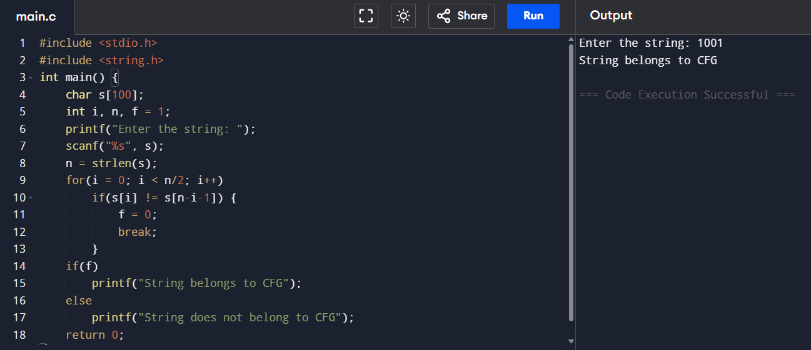
OUTPUT:

EXP-5:
AIM: Write a C program to check whether a given string belongs to the language defined by a Context Free Grammar (CFG) S → 0S0 | A A → 1A | ε
CODE:
#include <stdio.h>
#include <string.h>
int main() {
char s[100];
int i = 0, j;
scanf("%s", s);
j = strlen(s) - 1;
while (i < j && s[i] == '0' && s[j] == '0') {
i++;
j--;
}
while (i <= j && s[i] == '1')
i++;
if (i > j)
printf("Accepted");
else
printf("Rejected");
return 0;
}
OUTPUT:
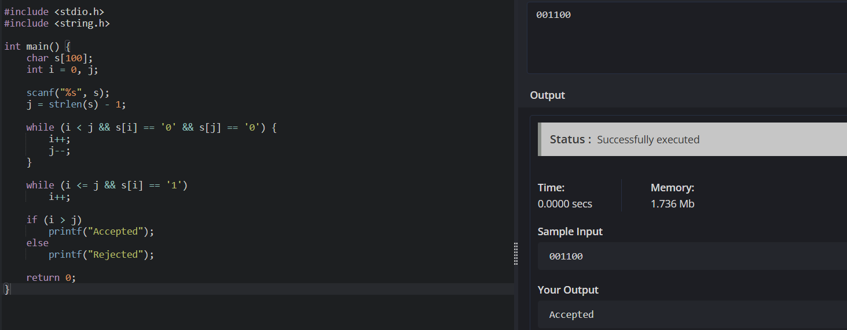
EXP-6:
AIM: Write a C program to check whether a given string belongs to the language defined by a Context Free Grammar (CFG) S → 0S1 | ε
CODE:
#include <stdio.h>
#include <string.h>
int main() {
char s[100];
int i = 0, c0 = 0, c1 = 0, n;
scanf("%s", s);
n = strlen(s);
while (s[i] == '0') { c0++; i++; }
while (s[i] == '1') { c1++; i++; }
if (i == n && c0 == c1)
printf("Accepted");
else
printf("Rejected");
return 0;
}
OUTPUT:
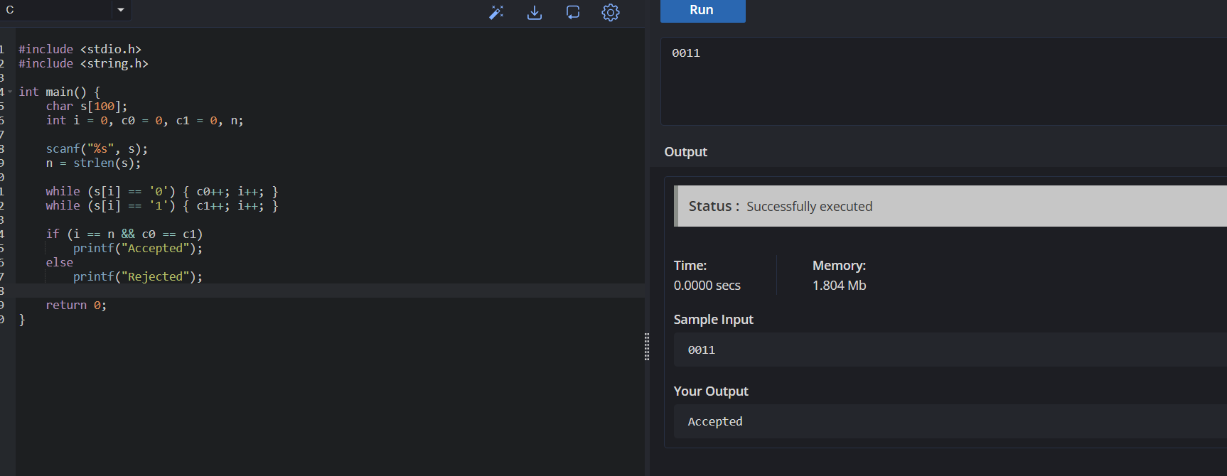

EXP-7:
AIM: Write a C program to check whether a given string belongs to the language defined by a Context Free Grammar (CFG) S → A101A, A → 0A | 1A | ε
CODE:
#include <stdio.h>
#include <string.h>

int main() {
char s[100];

scanf("%s", s);

if (strstr(s, "101"))
printf("Accepted");
else
printf("Rejected");

return 0;
}
OUTPUT:
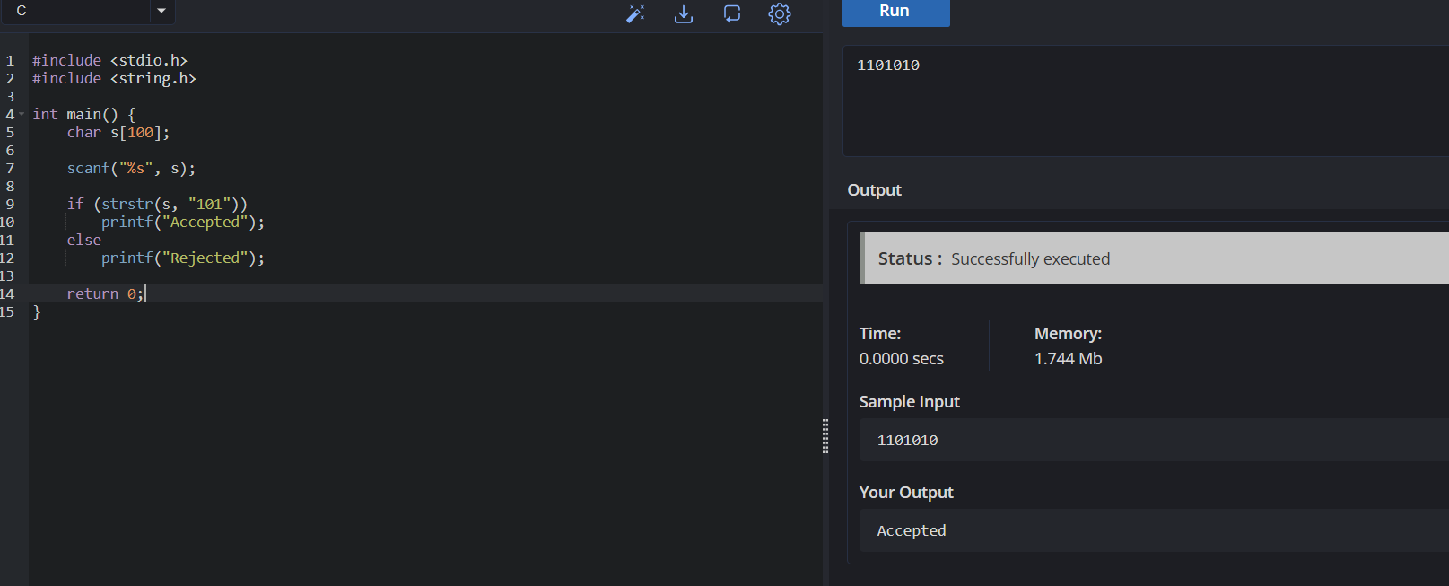

EXP 8:
AIM: To write and execute a C program to simulate a Non-Deterministic Finite Automata (NFA) that accepts strings starting with b and ending with a.
CODE:
#include <stdio.h>
#include <string.h>
int main() {
char str[100];
int n;
printf("Enter string: ");
scanf("%s", str);
n = strlen(str);
if (n > 0 && str[0] == 'b' && str[n - 1] == 'a')
printf("Accepted\n");
else
printf("Rejected\n");
return 0;
}
OUTPUT:

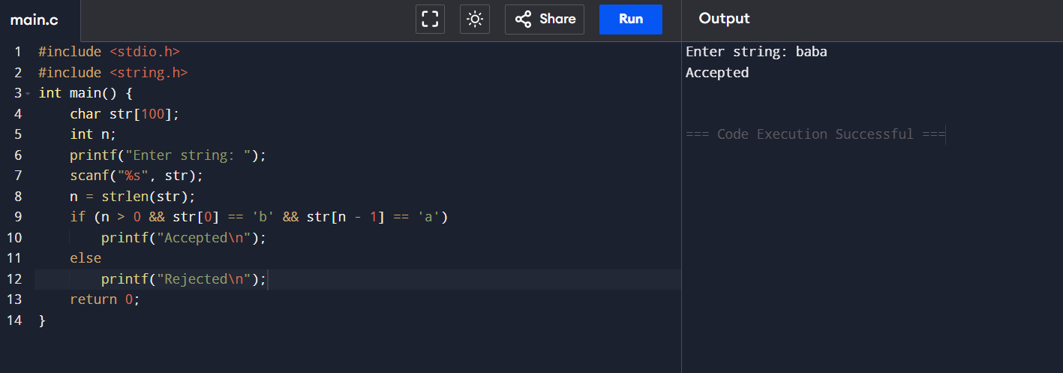

EXP:9
AIM: To write and execute a C program to simulate a Non-Deterministic Finite Automata (NFA) that accepts strings starting with 0 and ending with 1.
CODE:
#include <stdio.h>
#include <string.h>
int main() {
char str[100];
int n;
printf("Enter string: ");
scanf("%s", str);
n = strlen(str);
if (n > 0 && str[0] == '0' && str[n - 1] == '1')
printf("Accepted\n");
else
printf("Rejected\n");
return 0;
}
OUTPUT:

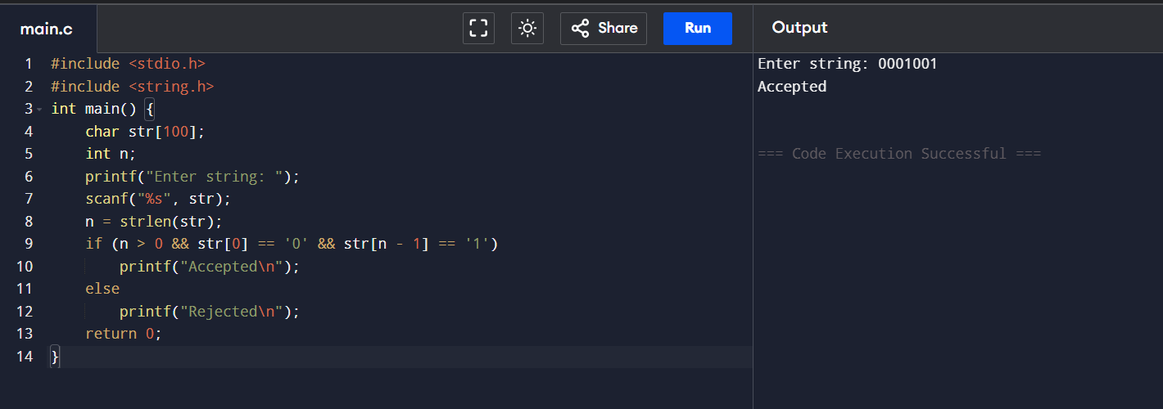

EXP:10
AIM: To write and execute a C program to find the ε-Closure of all states in a Non-Deterministic Finite Automata (NFA) with ε-transitions.
CODE:
#include <stdio.h>
int e[10][10], visited[10], n;
void eclosure(int s)
{
int i;
visited[s] = 1;
printf("q%d ", s);
for(i = 0; i < n; i++)
{
if(e[s][i] == 1 && !visited[i])
eclosure(i);
}
}
int main()
int i, j;
printf("Enter number of states: ");
scanf("%d", &n);
printf("Enter epsilon transition matrix:\n");
for(i = 0; i < n; i++)
for(j = 0; j < n; j++)
scanf("%d", &e[i][j]);
for(i = 0; i < n; i++)
{
for(j = 0; j < n; j++)
visited[j] = 0;
printf("E-Closure(q%d) = { ", i);
eclosure(i);
printf("}\n");
}
return 0;
}

OUTPUT:
